LGCWDW - ?????????
Colour key - Venn Pedro Jill

The Jill
https://meet.jit.si/jordan9000#config.disableAP=true&config.disableAEC=true&config.disableAGC=true

The Pedro
https://meet.jit.si/pedro9000#config.disableAP=true&config.disableAEC=true&config.disableAGC=true

News
Plugs
Pi
Feedback

Patreons: Post story suggestions HAR!
- Yabba dabba doo Linux
https://bedrocklinux.org/
- Audio FX for your Pulse
https://github.com/wwmm/pulseeffects
- OpenSnitch - application firewall
https://github.com/evilsocket/opensnitch
- Lubuntu drops 32 bit:
https://lubuntu.me/sunsetting-i386/
5. Slice of Pi:
https://twitter.com/ChrisJPatty/status/1078065910487760896

Rundown: You know the drill

What we’re up to :
V - I know where your “hidden” bootloader is, Amazon. Tune in next week for an episode of unlocked bootloader / bricked tablet.
J - Got a few more penguins over the Holidays to put on display!
Am going on vacation for the next 3 days to Disneyland :-D
P -

News

State of Desktop Linux 2019
https://www.linuxjournal.com/content/state-desktop-linux-2019
- Can 2019 be the year of realizing the desktop as a whole is a dying beast?
- I know you don’t want to hear that but it’s true.
- This is a very thoughtful and insightful article written by Bryan Lunduke, and he did a very good job in asking some of the key questions pondering Linux today to the leaders of Debian, Fedora and Elementary OS.
  - What do you see as the single biggest challenge currently facing both your specific project—and desktop Linux in general?
  - Is there value in the major distributions standardizing on package management systems? Should that be done? Can that be done?
- Decided lack of Canonical in the article.
- Love or hate they are 500lb gorilla of Desktop Linux.

My dear Watson
https://arstechnica.com/gadgets/2018/12/a-tour-of-elementary-os-perhaps-the-linux-worlds-best-hope-for-the-mainstream/
- That’s a bold claim there, Cotton!
- Though considering how neither Mac or Windows let you customize the desktop in any easy fashion, I can certainly see that side of the argument.
- Though, making the claim that this limited an environment is Linux’s best hope for mainstream, is taking a pretty big dump from atop your ivory tower on what a great deal of people like about Linux.
- Still, if Chrome’s adoption and subsequent success is anything to go by, maybe that is what people want.
- Though given the choice of current DEs, I’d probably vote for the deepin desktop enviroment or Budgie, if they dropped the b0rked mess that is mutter as a compositor.
- Elementary OS has gotten a lot of good press lately and has been introduced to a lot of new Linux users because of Jason Evangelho’s well written Forbes articles on Linux.
- Elementary OS is very easy to use, and uses its own Pantheon DM which is loved for its Mac like interface.

Bedrock Linux 0.7.1 (RTheren)
https://bedrocklinux.org/
- Roll your own nightmare!
- Can you imagine submitting a bug report if you’re a Bedrock Linux kinda person?
- The ultimate modular Linux distro combining elements from any of the distros.
- Imagine Debian stability with the latest Arch packages!

Accelerated Chrome OS
https://9to5google.com/2018/12/26/chrome-os-linux-apps-gpu-support/
- Good!
- I’d like to try some Steam games on my Acer R11.
- GPU support for containerized Linux apps in Chrome OS is so needed to increase speed and productivity.
- The Chrome OS VM needs to catch up to Wine in terms of GPU support.
- This is to help with rendering, not gaming.
- Another upcoming feature is blocking the USB ports on locked Chromebooks.

Blazing
https://www.omgubuntu.co.uk/2018/12/linux-4-20-released
- After the Snowden leaks the internet is not only justified to distrust the NSA, we’re right to do so.
- Someone hand me a tinfoil hat but, as someone who lives in the UK, the threat of an overbearing government authority is very much real.
- What’s wrong with encryption designed by NSA that the NSA refuses to answer questions about?
- Support for the Pine64 LTS and a bunch of Banana and Orange Pi boards are a very welcome sight.
- HDMI 2.0 support in nouveau is interesting, but good luck driving 4K at 60FerPS with the opensauce NVidia drivers.
- We got a Holiday present from Linus. Linux Kernel 4.20 has been released with lots of new updates!
- Support for the latest AMD Picasso and Raven 2 APUs.
- Yeah! Support for more sound cards including the higher end Creative Sound Blaster ZxR and AE-5 sound cards.
  - Now you can use an LED lit sound card on Linux for more bling!

Bounty
https://juliareda.eu/2018/12/eu-fossa-bug-bounties/
https://www.techspot.com/amp/news/78051-eu-fund-bug-bounties-open-source-projects-including.html
- Very good news for skilled people in need of some extra monies!
- PuTTY and DRUPAL swinging in with bounties up to $90k and $89k, respectively.
- Keep an eye on Intigriti and HackerOne for the results.
- EU to fund bug bounties for open source projects including PuTTY, Notepad++, KeePass, Filezilla and VLC, ranging from $30,000 to $100,000 per bug!
- Its part of their Free and Open Source Software Audit (FOSSA) project.
- As we talked about last week, in big business environments where the utmost security is needed, small independent developer code should not be used unless it is vetted and supported.
- This is a great solution to the problem, and encourages the community to help fix open source bugs and create “vetted” software.

Moz labs
https://www.ghacks.net/2018/12/28/mozilla-revives-mozilla-labs/
- Back from the dead, with a new domain.
- Projects focusing on virtual reality, speech and voice, and the Internet of Things.
- Moz labs will continue to focus on all things not browser.
- Like Google X but with actual products.
- The Firefox Reality virtual reality web browser is under the Mozilla Labs umbrella.
- One of my favourite discontinued Mozilla Labs projects that I was following was the Gladius 3D game engine, written entirely in JavaScript, and designed to run in the browser.
  - The CubicVR game engine is the basis for Gladius and Mozilla Labs WebGL projects.

Top Snaps
https://blog.ubuntu.com/2018/12/27/top-snaps-in-2018
- You know what I don’t see and it still irks me to no end?
- A change from that stupid lowercase folder snaps put in the root of your $HOME directory.
  - Yes, having /snap in my home directory has caused me countless hours of anger and confusion.
- Also, Notepad++? WAT?!
- Have people not heard of geany?
- Or nano with syntax highlighting?
  - These are the type of people who get software from a snap repo.
- The Shortcut video editor snap is really quite nice and updated regularly.
- Xonotic, cool!
- I love the fact that Alan Pope and Martin Wimpress have been working on linux gaming snaps.
  - And Wine emulated apps and game snaps, such as TrackMania Nations Forever!
- 18.04 don’t know how to Snap.
- 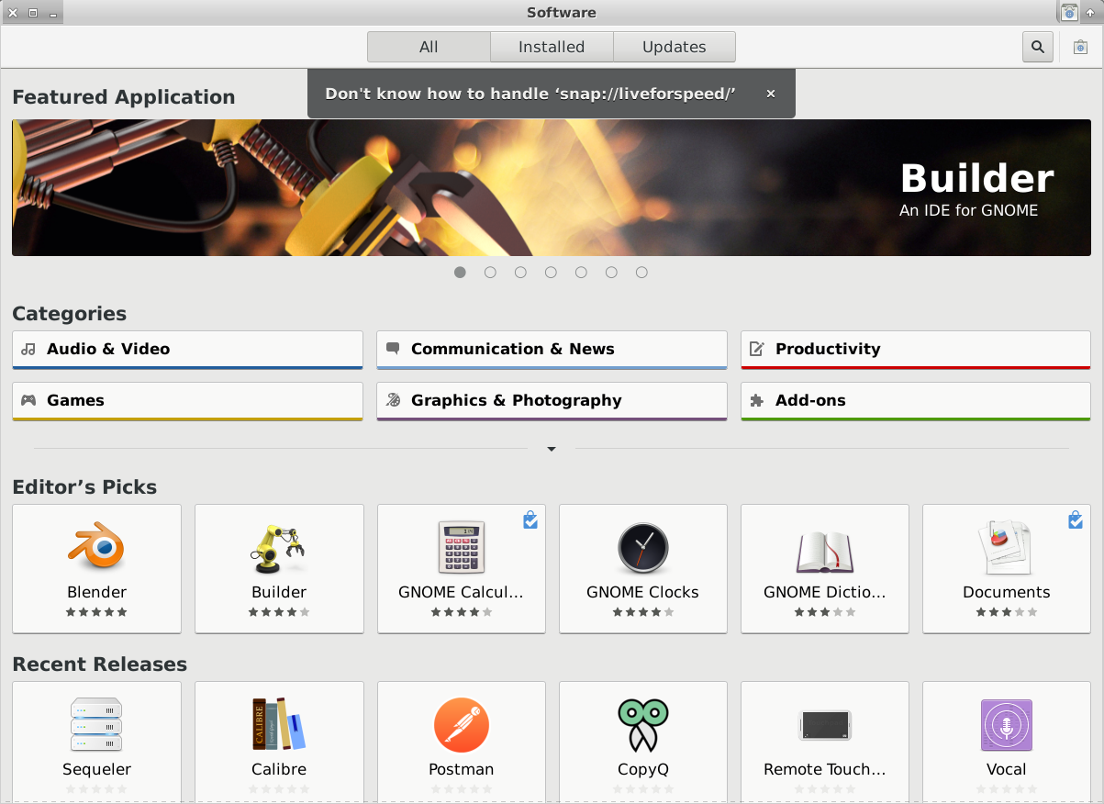

Marco
https://itsfoss.com/polo-file-manager/
- You can pay an extra $10 for “advanced features”
- If you want to try it in Solus, here’s a link with the dep list: https://dev.getsol.us/T7001
  - Install the dev packages for all those if you want to build it from sauce.
- Polo has a very clean and modern user interface, and reminds me a bit of well, almost every other modern file manager available, such as Nautilus, Dolphin, Thunar, Caja etc.
- The support for cloud storage via Dropbox, Google Drive, Amazon Drive etc. is a nice feature and easy to setup.
- The paid version includes the ability to write ISOs to flash drives, image optimization and adjustment tools, PDF editing tools and video downloading via youtube-dl.
  - All of which I already do with external applications which I link to in the file managers I already use, like emelFM2, PCManFM, Thunar etc.

Plugs

Kim O (increased pledge)
Alexandr (new)

Slice of Pi

24 banana
https://www.cnx-software.com/2018/12/26/banana-pi-24-core-arm-server/
- 24-core Arm Cortex A53 processor with 32GB RAM (29.4GB seen by the OS) running Ubuntu 18.04.1 LTS with MATE desktop.
- SATA ports and support for NVME.
- Priced in the “if you have to ask” category.
- Tested TensorFlow and Nextcloud under Docker, Raspbian and The Robot Operating System (ROS) framework Melodic Morenia.
- I am curious as to how big a hole one of these would punch in one’s wallet!

Feedback

Syg
https://linuxgamecast.com/bradley/?zFoyfoh
https://www.youtube.com/watch?v=itmPIgL_kQQ&t=1558s

Bookem
https://linuxgamecast.com/bradley/?IYtJVnu

